http://www.problem-attic.com/
You should have received earlier in the year an activation. If you did not activate your account earlier in the year to set your password, search in your inbox now for support@problem-attic.com . Click on the link provided to make a password.
If you do not have an activation email, have one of the presenters send you an activation email.
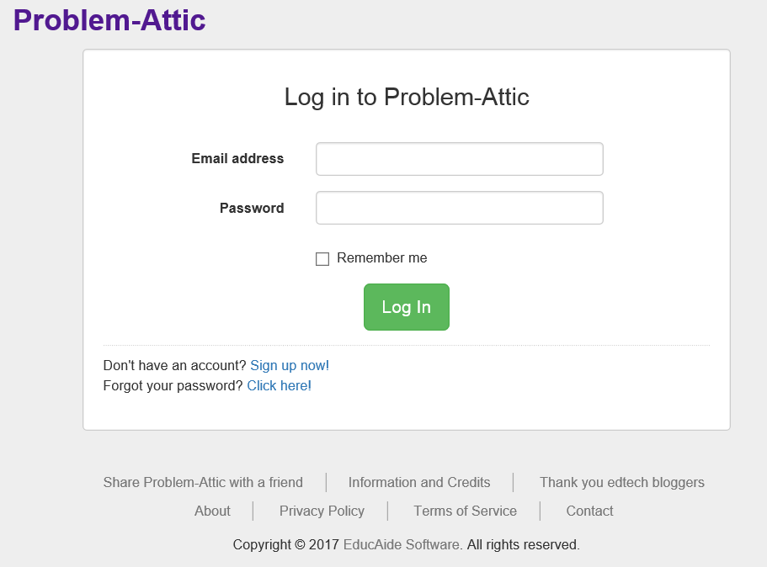 Click on new Document

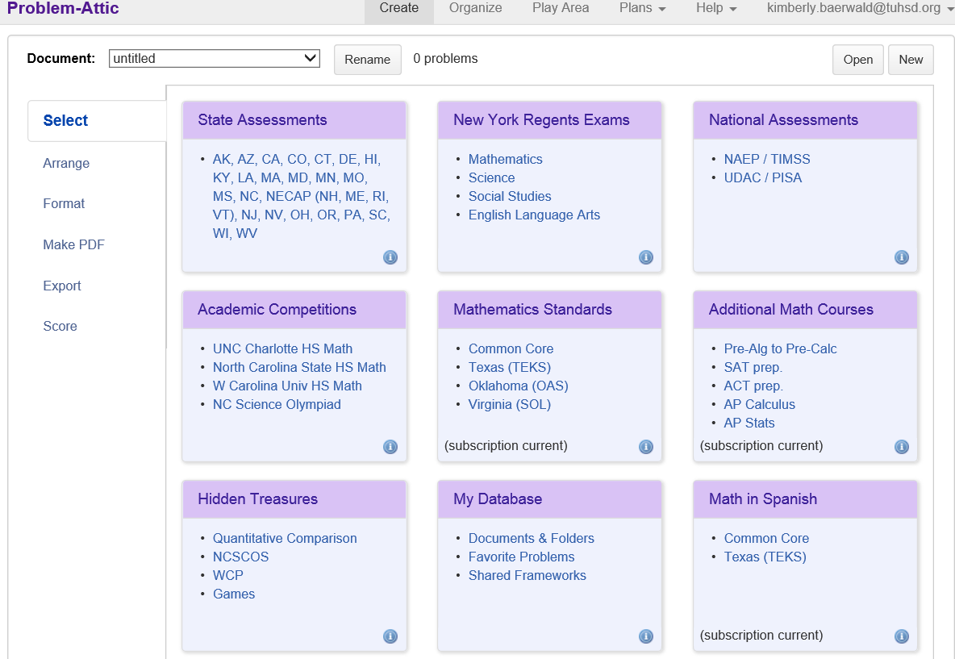

If you want the document to start with 0 problems leave it on blank document. If you want to start with problems you developed from another document (like a spiral review), use the drop down list to start with that document.
Put the name here in title. Agree upon a common naming convention.
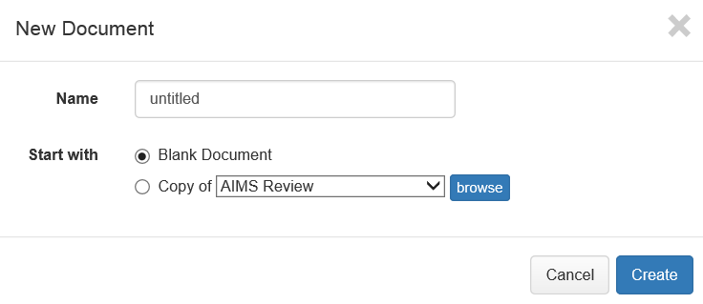
You have many many test banks to choose from. The primary source for AIMS Science will the state assessments in the top left hand corner.
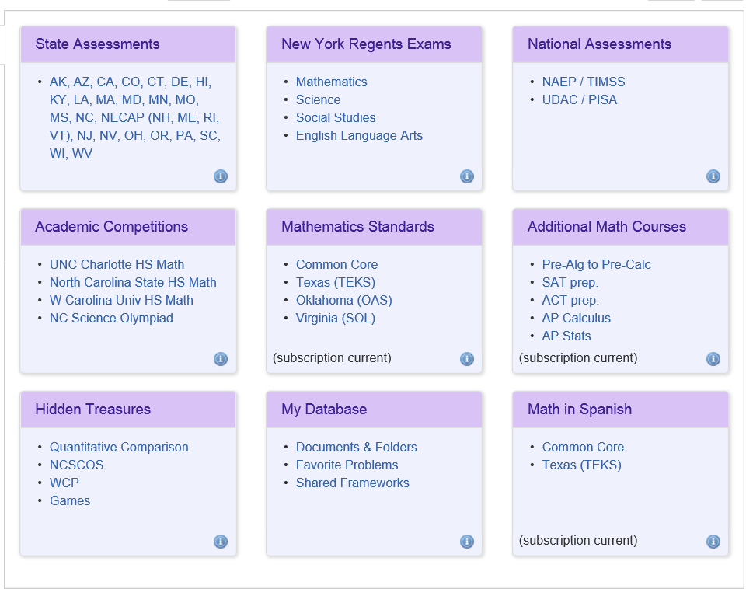

Click on the middle tab, Science
You have several topics to choose problems.
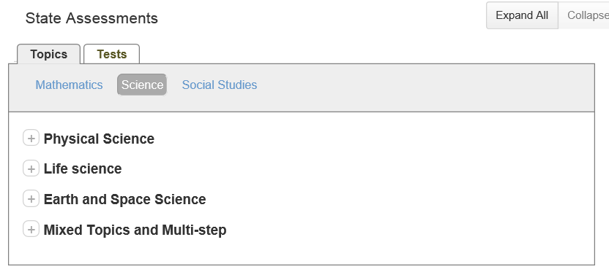
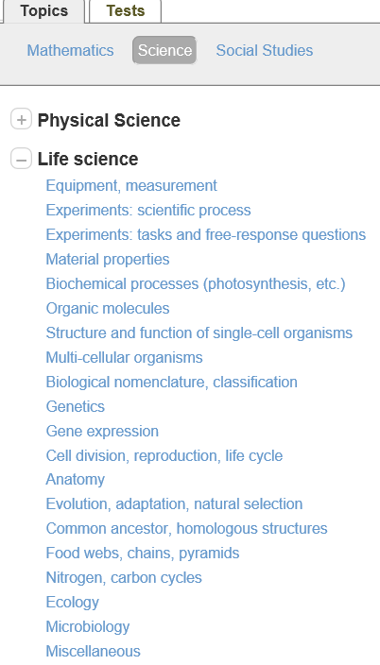
And subtopics beneath the topics!!!
You also have the option of choosing the test tab!
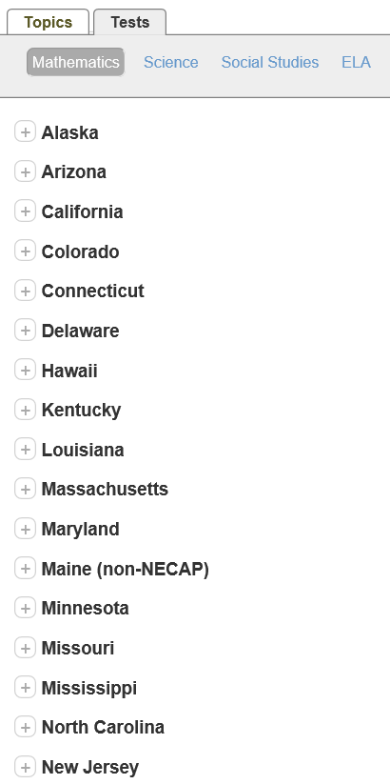
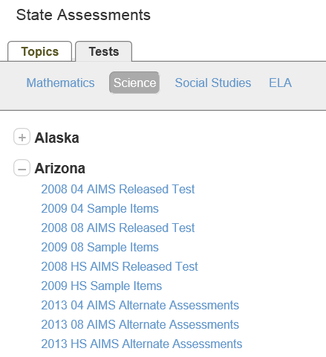

Once you pick a topic and a subtopic you will now begin to see problems to select (or not) 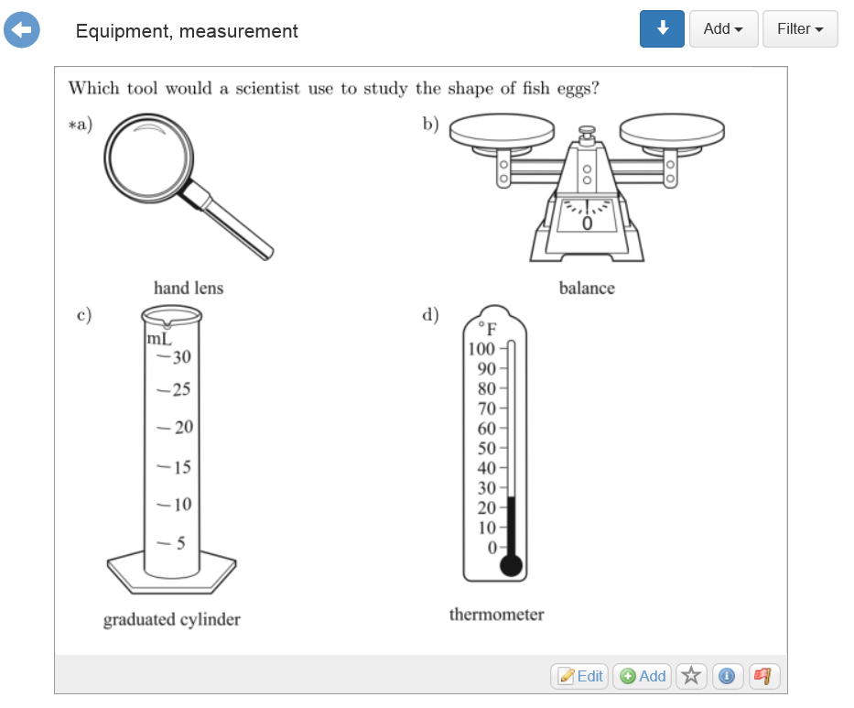
You simply click on the button Add
You can switch lists or topics to continue to add questions. The limit for one document is 200 questions (I think).

Once you are finished adding questions, you use the buttons on the left hand side to make your pdf.
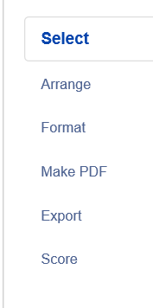
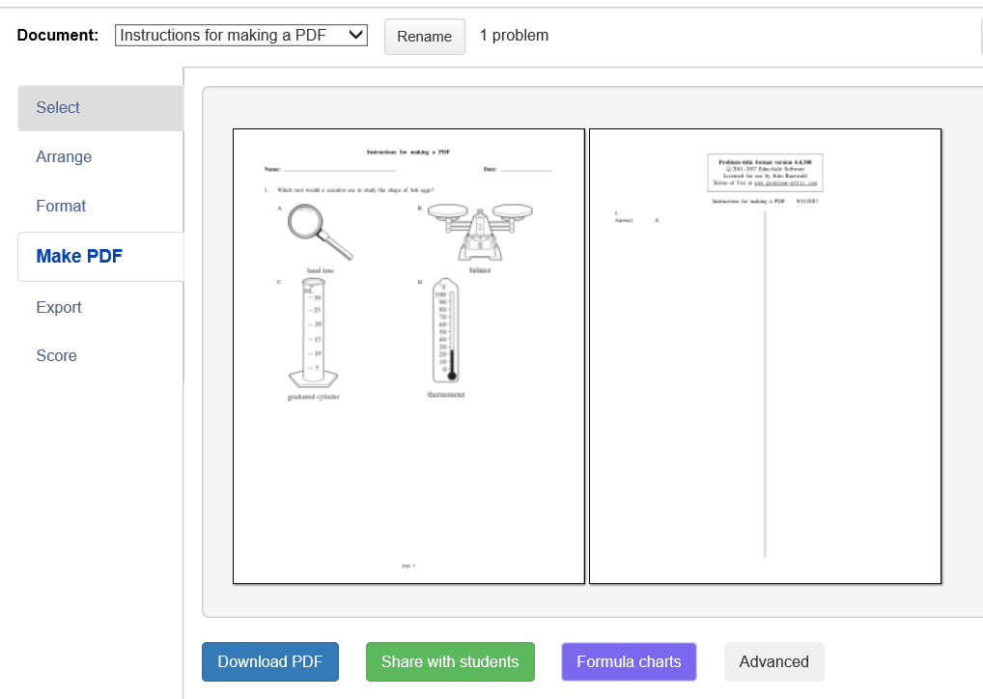
This screen appears. Now you want to download the pdf. Use the naming convention and save to the s:drive where your facilitators indicate you should put the review document.
Now use the skills you learned to make an Answer Key Only (AKO) document in SchoolCity. You need to assign a standard to every question you selected.

